Issue :-

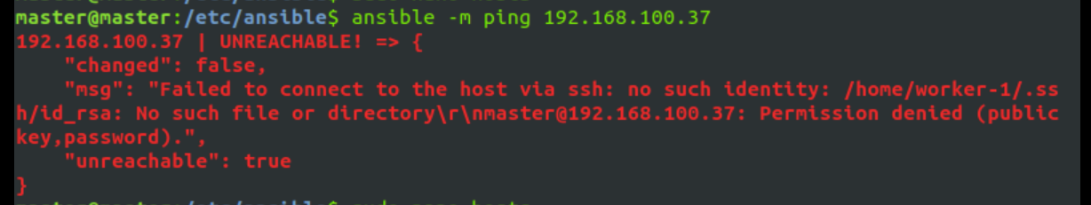

192.168.100.37 | UNREACHABLE! => { "changed": false, "msg": "Failed to connect to the host via ssh: master@192.168.100.37: Permission denied (publickey,password).", "unreachable": true }

Solution :-

This is comes due to ansible host configuration in hosts/inventory file

* Go to ansible hosts file cd /etc/ansible/hosts and edit server group

[webserver]

“Ip of ansible remote node” “mention ansible user for worker node” mention “ansible_ssh_private_key_file=/path/to/your/id_rsa”

Example :

[webserver]

192.168.100.37 ansible_user=worker-1 ansible_ssh_private_key_file=/home/master/.ssh/id_rsa

#this path /home/master/.ssh/id_rsa is of your ansible server private key because to allow remote connection

* Now issue got fixed

Issue: "UNREACHABLE" error message when using Ansible to connect to a remote host.

Explanation:

The error message you encountered, which reads "192.168.100.37 | UNREACHABLE! => {...}", indicates that Ansible was unable to establish an SSH connection with the target host at IP address 192.168.100.37. The specific error message, "Permission denied (publickey,password)," suggests that there was an issue with the SSH authentication process, and Ansible couldn't access the remote host.

Solution:

Check Ansible Inventory:

The root cause of this issue typically lies in the Ansible inventory configuration. The inventory file defines the hosts and their associated parameters. To resolve the problem, follow these steps:

Locate and edit the Ansible inventory file. The default path is often /etc/ansible/hosts:

cd /etc/ansible/hosts

* **In the inventory file, identify the group corresponding to the target host. In your case, it appears to be "[webserver]."**
* **Within the group, specify the following parameters:**
  + **The IP address of the remote host.**
  + **The correct Ansible user to use when connecting to the remote host.**
  + **The file path to the SSH private key on the Ansible control machine (your machine).**

**Example:**

**[webserver]**

**192.168.100.37 ansible_user=worker-1 ansible_ssh_private_key_file=/home/master/.ssh/id_rsa**

* + - **Ensure that the ansible_user parameter is set to the appropriate user for the remote node (in this case, "worker-1").**
    - **Specify the correct file path for the ansible_ssh_private_key_file. This should point to the private key on your Ansible control machine. The provided example assumes it's located at /home/master/.ssh/id_rsa.**

1. **Update and Test: Save the changes to your inventory file and re-run your Ansible command. The corrected configuration should enable Ansible to connect to the remote host successfully.**